Visualization Set Up Instructions

The following set up procedure (10 steps) should be followed to properly carry out the visualization of the C++ Cell-DEVS minefield mapping simulation:

1. Install Blender from http://download.blender.org/release/Blender2.43/blender-2.43-windows.exe
2. Install Python version 2.4 from http://www.python.org/ftp/python/2.4.4/python-2.4.4.msi
3. Place **mineclear3blocks.blend** in C:\Program Files\Blender Foundation\Blender\.blender
4. Place **minefield_gui_v11.py** in C:\Program Files\Blender Foundation\Blender\.blender\scripts. ***\*\*Delete any previous gui scripts from either P. Castonguay (ac_evac_gui.py)***

***or E. Poliakov (gui.py).***

1. Place **MineClear4Robots.ma**, **MineClear4Robots.val**, and **MineClear4Robots.log** in   
   C:\Program Files\Blender Foundation\Blender\.blender
2. Open **mineclear3blocks.blend**. This can be done one of two ways:
   * by double clicking on the file in the C:\Program Files\Blender Foundation\Blender\.blender folder; OR
   * in Blender, from the File menu, select Open and the proper file.
3. Load the **CD++ Simulations** script. See the following screen capture.

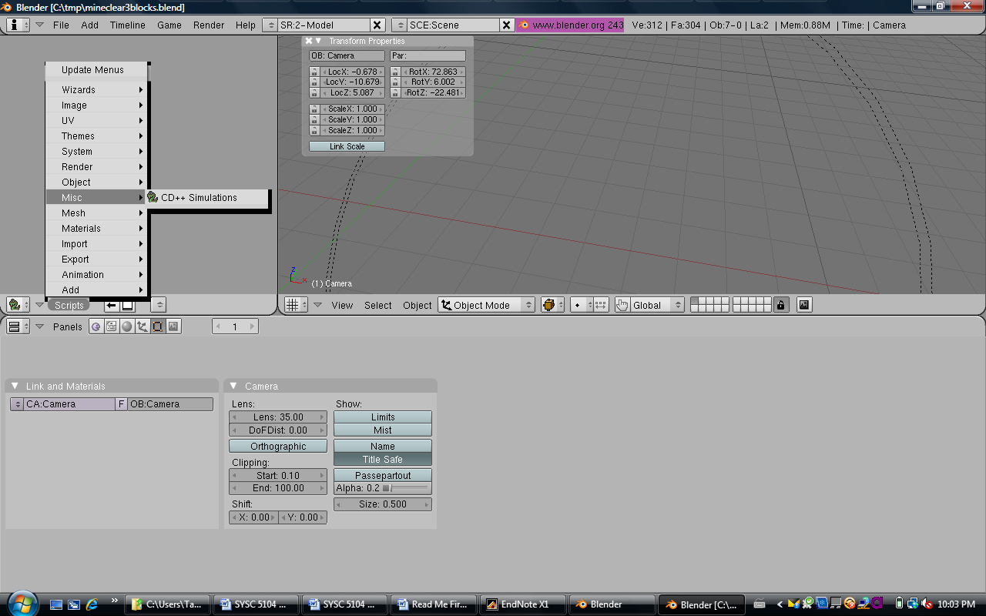

2

3

1

1. In the script GUI, select **MineClear4Robots.ma** and **MineClear4Robots.log** by browsing the .blender folder, if they are not already selected. See the following screen capture.

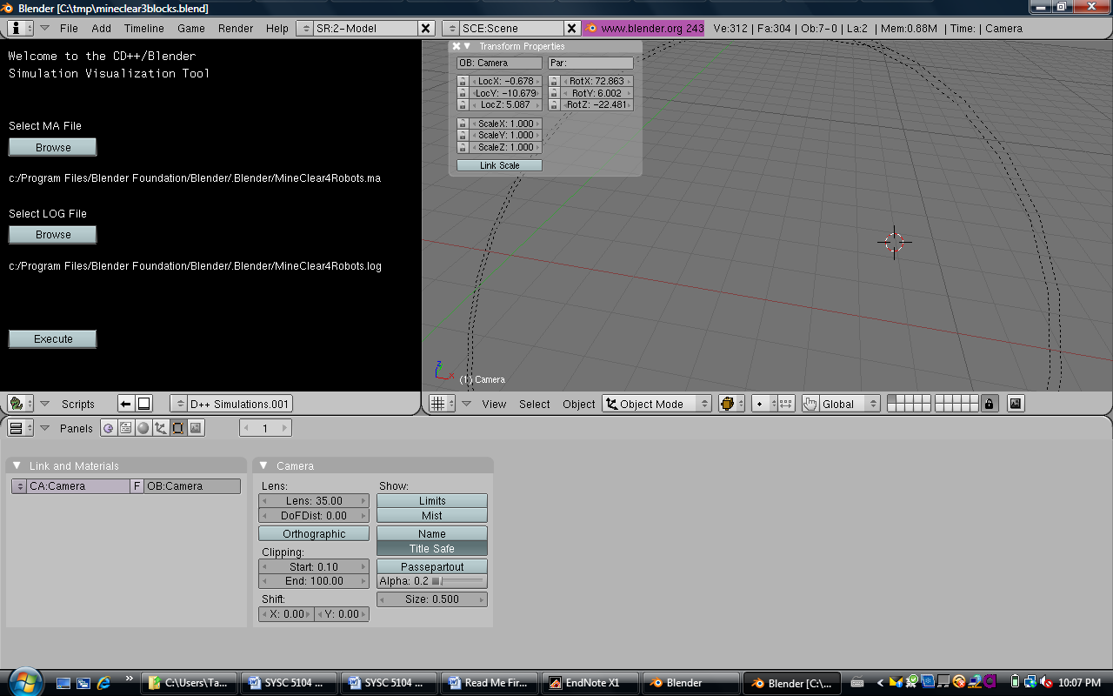

1. Hit the Execute button in the script GUI



1. Watch the 3D visualization ☺